- List the Dos and Don’t of Data Flow Diagram

Do’s | Don’t
Data can flow from  External Entity to Process  Process to External Entity  Process to Data Store and back  Process to Process | Data cannot flow from  External entity to External Entity  External entity to store  Data store to External Entity  Data store to Data Store

- Given the Table Employee, Identify 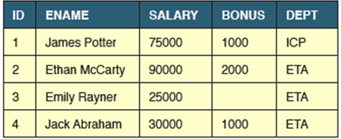
- Tuples : 4
- Domain : {ICP,ETA}
- Attributes :ID,ENAME,SALARY,BONUS,DEPT
- Degree of the Relation :5
- Cardinality of the Relation : 4

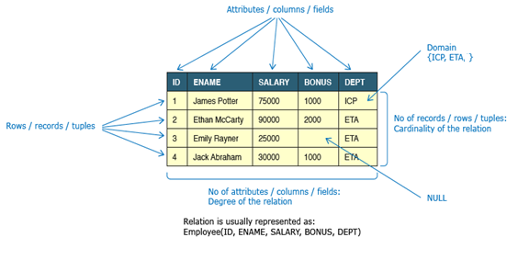

- Give the Table look into the attributes and values Identify how many superkeys could be constructed
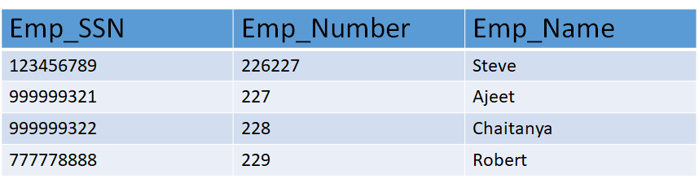

superkeys could be constructed : 6
{Emp_SSN}
{Emp_Number}
{Emp_SSN, Emp_Number}
{Emp_SSN, Emp_Name}
{Emp_SSN, Emp_Number, Emp_Name}
{Emp_Number, Emp_Name}

- Who is a DBA and List his roles

DBA is the person or group that is responsible for supervising both the data base and the use of the DBMS

- Policy Formulation and Implementation
- Access privileges
- Security
- Disaster planning
- Archives
- Data Dictionary Management
- Training
- DBMS Support
- DBMS evaluation and selection
- DBMS responsibility
- Data Base Design

- Patients are treated in a single ward by the doctors assigned to them.
Usually each patient will be assigned a single doctor, but in rare cases they will have two. Healthcare assistants also attend to the patients, a number of these are associated with each ward.

Identify the Entity, Cardinality and Relationships

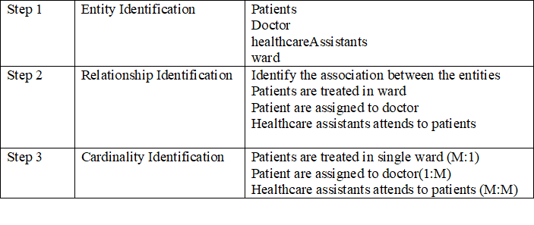
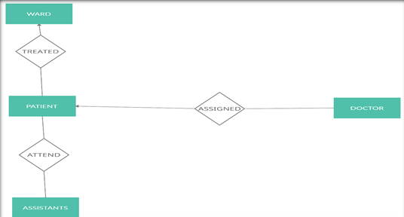

- Identify the Primary key and Foreign key of both the Tables

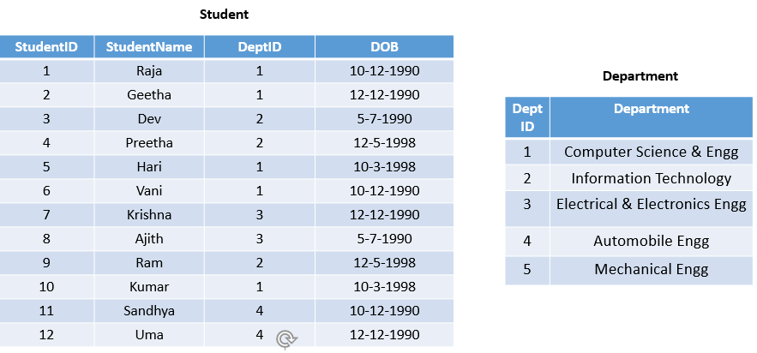

Student Table  Primary Key : StudentID  Foreign Key : DeptID | Department Table  Primary Key : DeptID  Foreign Key : None

- Write the basic Structure of SQLquery with an example

select A1, A2, . . . , An
from r1, r2, . . . , rm
where P;

- In the select clause, you have to specify the attributes that you want to see in the result relation
- In the from clause, you have to specify the list of relations that has to be accessed for evaluating the query.
- In the where clause involves a predicate or condition that we have listed in the from clause.

select name from instructor;
select distinct dept_name from instructor;
select * from instructor where dept_name=’Biology’;

- What is Null Value and write the syntax of creating a table with not null columns?

The SQL NULL is the term used to represent a missing value. A NULL value in a table is a value in a field that appears to be blank.

A field with a NULL value is a field with no value. It is very important to understand that a NULL value is different than a zero value or a field that contains spaces.

BASIC SYNTAX OF NULL WHILE CREATING A TABLE.
SQL> CREATE TABLE CUSTOMERS(
ID INT NOT NULL,
NAME VARCHAR (20) NOT NULL,
AGE INT NOT NULL,
ADDRESS CHAR (25) ,
SALARY DECIMAL (18, 2),
PRIMARY KEY (ID)
);

- Write the relational Algebra representation for the following query
- Display all the student Names from Course and Student Table
- Display the student names who appear in both the tables
- select those student names that are present in STUDENT table but not present in COURSE table.

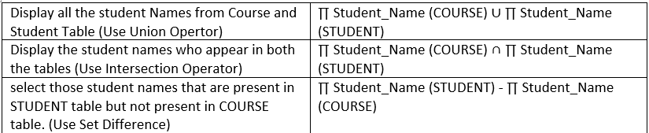

- Given the customer table, Write the relational Algebra representation for the following query
- Display all customers who belong to the city delhi
- Display the Customer_Id and Customer_Name from the customer Table
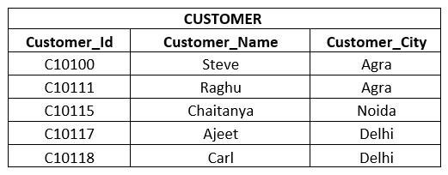
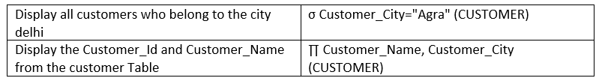

- What is Join and Mention the Types of Join

SQL JOINS are used to retrieve data from multiple tables.
Types of Joins

- Inner Join
- Left Outer Join
- Right Outer Join
- Full Join

- What is view and list the types of Views

A view is a virtual or logical table that allows to view or manipulate parts of the tables.To reduce REDUNDANT DATA to the minimum possible, Oracle allows the creation of an object called a VIEW.
View is a Virtual Table that does not Physically exist.
Used to customize the database based on users perception
Security mechanisms is enforced by not directly accessing the underlying base table

CREATE VIEW view_name AS
SELECT column1, column2, ...
FROM table_name
WHERE condition;

Types of views :
Read-only View : Allows only SELECT operations.
Updateable View : Allows SELECT as well as INSERT , UPDATE and DELETE operations.

- What is an Aggregate Function? List its Types

SQL aggregation function is used to perform the calculations on multiple rows of a single column of a table. It returns a single value.
It is also used to summarize the data.

Types of SQL Aggregation Function
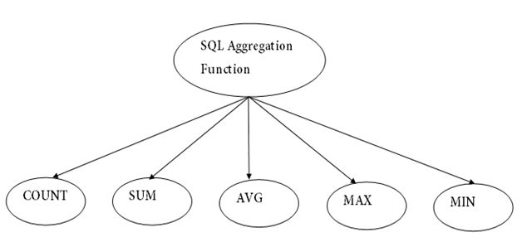

- Differentiate Groupby and Order by Clause in SQL

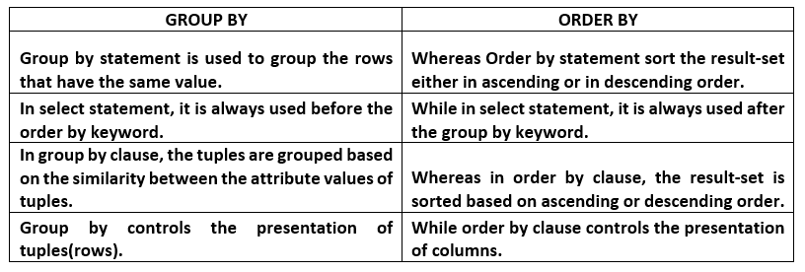

- What is Trigger and List its advantages
TRIGGERS are stored programs that are fired by Oracle engine automatically when DML Statements like insert, update, delete are executed on the table or some events occur.
The purpose of trigger is to maintain the integrity of information on the database.

- Generating some derived column values automatically
- Enforcing referential integrity
- Event logging and storing information on table access
- Auditing
- Synchronous replication of tables
- Imposing security authorizations
- Preventing invalid transactions

- Define Boyce Codd Normal Form

It is an advance version of 3NF that’s why it is also referred as 3.5NF.
BCNF is stricter than 3NF.
A table complies with BCNF if it is in 3NF and for every functional dependency X->Y, X should be the super key of the table.

- What is First and Second Normal Form?

First Normal Form
Each Column should contain only atomic values.

Second Normal Form
Table is in 1NF (First normal form)
No non-prime attribute is dependent on the proper subset of any candidate key of table.
All the columns depend on the table’s primary key.

- Differentiate Functions and Procedures in PL/SQL

Procedure | Function
- Used mainly to a execute certain process | - Used mainly to perform some calculation
- Use OUT parameter to return the value | - Use RETURN to return the value
- It is not mandatory to return the value | - It is mandatory to return the value
- RETURN will simply exit the control from subprogram. | - RETURN will exit the control from subprogram and also returns the value
- Return datatype will not be specified at the time of creation | - Return datatype is mandatory at the time of creation
- The procedure allows SELECT as well as DML(INSERT/UPDATE/DELETE) statement | - Function allows only SELECT statement in it.
- Procedure cannot be embedded in a SELECT statement.  - SUM,AVG,COUNT and even | - Function can be embedded in a SELECT statement.  - SUM,AVG,COUNT and even
- What is Functional Dependency and List its Types

An attribute in a relational model is said to be functionally dependent on another attribute in the table if it can take only one value for a given value of the attribute upon which it is functionally dependent.
- Multivalued Dependency
- Trivial Functional Dependency
- Non-Trivial Functional Dependency
- Transitive Dependency
PART – B
- Explain Entity Relationship Diagram with an Example

The ER model consists of basic objects called entities and a relationship among these objects.
Proposed by Peter Pin-Shan Chen (1976).
Three basic notations in ER model are
Entity sets
Relationship sets
Attributes

Attributes Types
Simple and composite attributes
Single valued and multi valued attributes
Null attributes
Derived attributes
Simple attributes
The attributes simple in its structure, which cannot be further sub divided are referred as simple attributes. Eg: sex,etc.

Composite attributes:  The attribute may be composed of several components. It can be further sub divided Address(Apt#, House#, Street, City, State, ZipCode, Country)  Name(FirstName, MiddleName, LastName). | 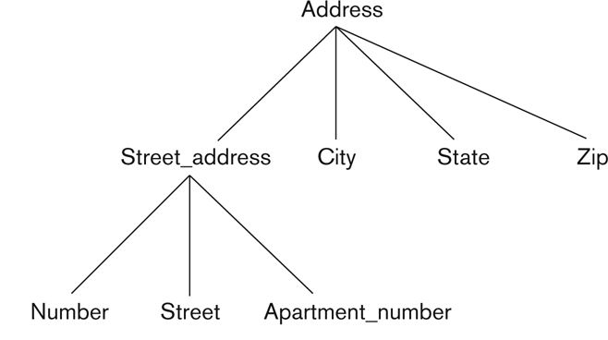
Single values attributes  Attributes have single value for particular entity | eg: loan number attribute has a single loan number
Multivalued attributes  Attributes has a set of values for a specific entity consider an employee entity set dependent-name an employee can have zero, one or more dependents | In bio data-references-names  Educational qualifications sslc,hsc,ug,pg
Null attributes  A null value is used when an entity does not have a value for an attributes | Eg: One may have no middle name.
Derived attribute  The value for this type of attribute can be derived from the values of other related attributes/entities | Given DOB, derive an Attribute called as Age

More than one relationship between entities

There can be more than one relationship between entities, e.g. an Employee works in a Department while the head of department (also an employee) manages a Department.
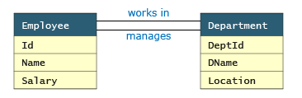

Recursive Relationship
If the same entity participates more than once in a relationship it is known as a recursive relationship. In the below example an employee can be a supervisor and be supervised, so there is a recursive relationship.
Eg: A women can take up the role of a wife, mother, daughter-in-law etc.

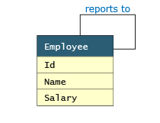

Degree of Relationships

The number of roles in the relationship
Binary – links two entity sets; set of ordered pairs (most common)
Ternary – links three entity sets; ordered triples (rare). If a relationship exists among the three entities, all three must be present
Ternary relationship set involving the entity sets customer, loan, branch.. customer jones, loan – L-17 and the perryridge branch.
N-ary – links n entity sets; ordered n-tuples (very rare). If a relationship exists among the entities, then all must be present. Cannot represesnt subsets.

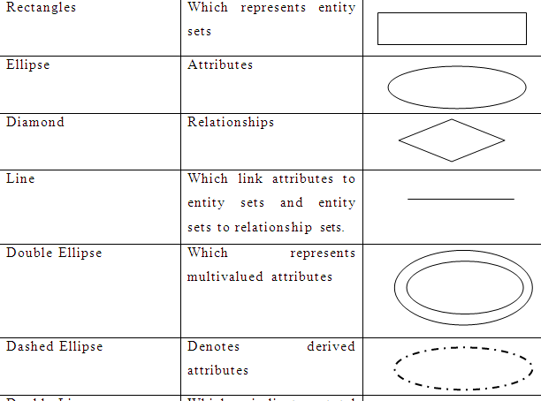

How to Create an Entity Relationship Diagram (ERD)

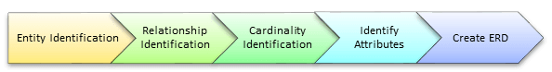

In a university, a Student enrolls in Courses. A student must be assigned to at least one or more Courses. Each course is taught by a single Professor. To maintain instruction quality, a Professor can deliver only one course
Step 1: Entity Identification
Student
Course
Professor

Step 2 : Relationship Identification  Identify the association between the entities  The student is assigned a course  Professor delivers a course | 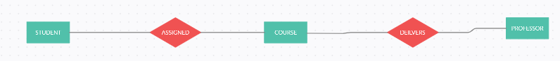
Step 3) Cardinality Identification
A student can be assigned multiple courses
A Professor can deliver only one course

Step 4) Identify Attributes
  Entity | Primary Key | Attribute
  Student | Student_ID | StudentName
  Professor | Employee_ID | ProfessorName
  Course | Course_ID | CourseName

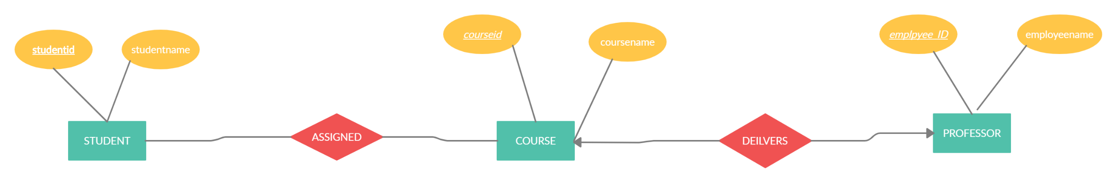

- Explain the Concept of Data Flow Diagram, Its need in project Development with a Case Study as an example
- A picture is worth a thousand words.
- A Data Flow Diagram (DFD) is a traditional way to visualize the information flows within a system.
- It shows
  - how information enters the System
  - How Information leaves the system
  - what changes the information
  - where information is stored.

An external entity, which are also known as terminators, sources, sinks, or actors, are an outside system or process that sends or receives data to and from the diagrammed system | 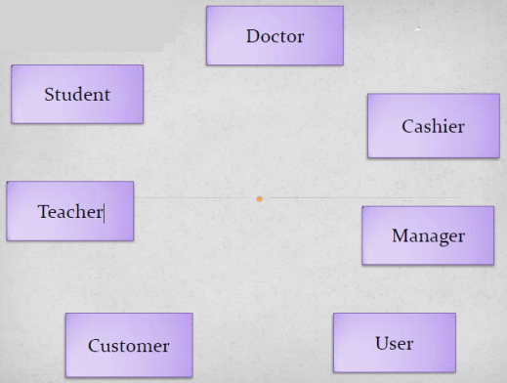
A process is a unit of work that operates on the data
The rounded cornered rectangles or circles in a DFD indicate processes
Process is a procedure that manipulates the data and its flow by taking incoming data, changing it, and producing an output with it
Opened sided rectangles in DFD indicates data store.
Data flow is the path the system’s information takes from external entities through processes and data stores. With arrows and succinct labels, the DFD can show you the direction of the data flow.
Arrow symbol in DFD indicate data flow

Rules of Data Flow | Rules of Data Flow | Four rules of thumb to create a valid DFD.
Data can flow from  - External Entity to Process  - Process to External Entity  - Process to Data Store and back  - Process to Process | Data cannot flow from  - External entity to External Entity  - External entity to store  - Data store to External Entity  - Data store to Data Store | Each process should have at least one input and one output.  Each data store should have at least one data flow in and data flow out.  A system’s stored data must go through a process.  All processes in a DFD must link to another process or data store.

Creating Data Flow Diagrams – LEMONADE EXAMPLE

Create a list of activities | Customer Order  Produce Product  Serve Product  Collect Payment  Store Product
Also think of the additional activities needed to support the basic activities. | Customer Order  Produce Product  Serve Product  Collect Payment  Store Product  Order Raw Materials  Pay for Raw Materials  Pay for Labor
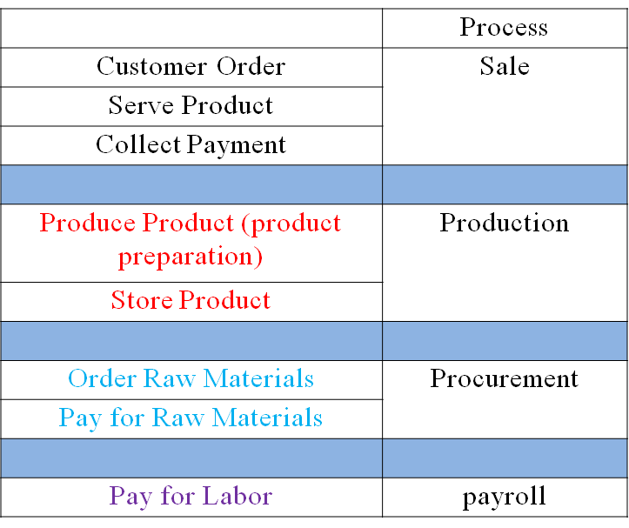
Identify the main system (Lemonade)  Identify the external people who interact with the system  Customer  Employee (Seller)  Vendor (for purchasing Raw Materials)  Decide what data these entities will enter into the system  Determine what these entities expect as output from the system  Context level DFD’s demonstrates the interactions between the process and external entities.  They do not contain Data Stores. | 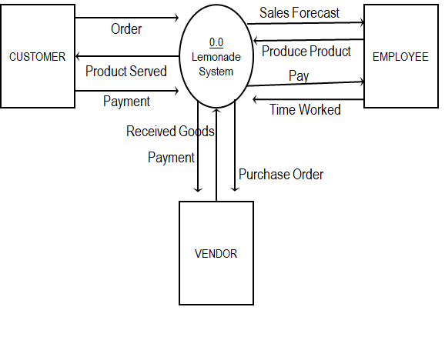
Create a level 0 diagram identifying the logical subsystems that may exist.  Customer Order  Serve Product  Collect Payment  Produce Product  Store Product  Order Raw Materials  Pay for Raw Materials  Pay for Labor | 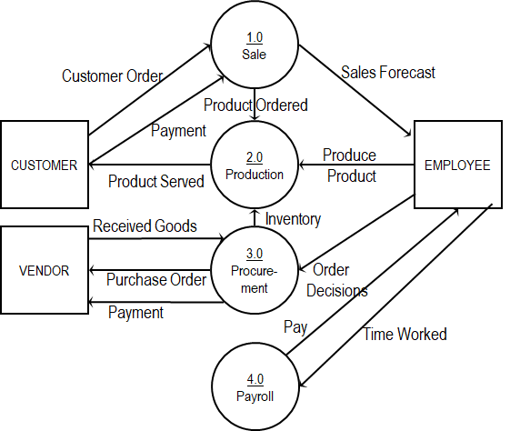
 | 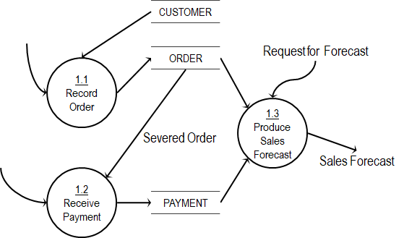
 | 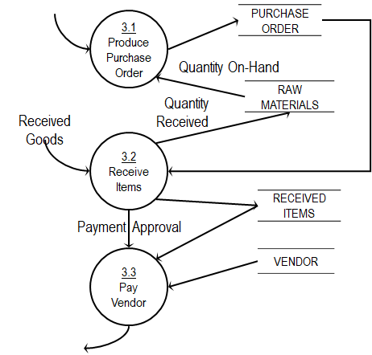
 | 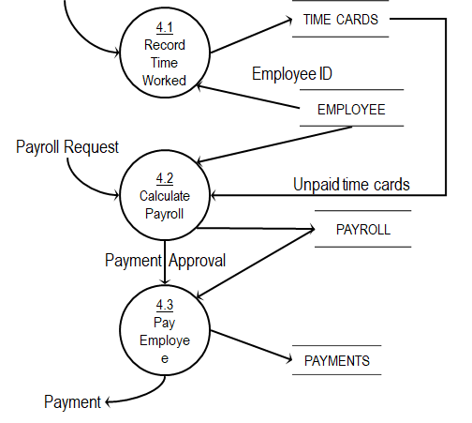

- Explain DBMS Architecture and the three levels of Abstraction

- Explain DDL, DMLand TCL commands with examples

- Write the Syntax for the following
- Create a Table for Student with 5 fields and Department with 2 fields and appropriate constraints which includes Primary Key, Not Null, Check, Unique and Foreign Key.
- Looking records pagewise if it contains more records
- How to modify multiple columns of a table
- How to drop column of a table
- How to rename table
- How to Insert records to a table Interactively
- Update all the records of a Table
- Delete the records of an table based on a condition
- Creating Table With Primary Key And Constraint Name Specified
- How to check the default value option for a column

Create a Table for Student with 5 fields and Department with 2 fields and appropriate constraints which includes Primary Key, Not Null, Check, Unique and Foreign Key.

SQL> CREATE TABLE DEPT1(DNO NUMBER(2) PRIMARY KEY, DNAME VARCHAR2(12) UNIQUE);

Table created.

SQL> DESC DEPT1;
Name Null? Type
----------------------------------------- -------- ----------------------------
DNO NOT NULL NUMBER(2)
DNAME VARCHAR2(12)

CREATE TABLE STU1(SNO NUMBER(3) PRIMARY KEY, STUNAME VARCHAR2(15) NOT NULL, STUAGE NUMBER(2) CHECK (STUAGE>= 18), DNO NUMBER(2) REFERENCES DEPT1(DNO))

SQL> /

Table created.

SQL> DESC STU1;
Name Null? Type
----------------------------------------- -------- ----------------------------
SNO NOT NULL NUMBER(3)
STUNAME NOT NULL VARCHAR2(15)
STUAGE NUMBER(2)
DNO NUMBER(2)

Looking records pagewise if it contains more records

SELECT * FROM USER_TABLES;
SET PAUSE ON;
SQL> set pause "Hit enter"
So that you can actually see when to hit the enter key.

How to modify multiple columns of a table

ALTER TABLE table_name
MODIFY (column_1 column_type,
column_2 column_type,
...
column_n column_type);

ALTER TABLE customers
MODIFY (customer_name varchar2(100) not null,
city varchar2(100));

How to drop column of a table

ALTER TABLE table_name
DROP COLUMN column_name;

ALTER TABLE customers
DROP COLUMN customer_name;

How to rename table

ALTER TABLE table_name
RENAME TO new_table_name;

How to Insert records to a table Interactively

SQL> INSERT INTO PERSONS1 VALUES(&ID,'&LASTNAME','&FIRSTNAME',&AGE);
Enter value for id: 1
Enter value for lastname: NIRMALA
Enter value for firstname: M
Enter value for age: 43
old 1: INSERT INTO PERSONS1 VALUES(&ID,'&LASTNAME','&FIRSTNAME',&AGE)
new 1: INSERT INTO PERSONS1 VALUES(1,'NIRMALA','M',43)

1 row created.

Update all the records of a Table

Update stu set marks = m1+m2+m3;

Delete the records of an table based on a condition

Delete from stu where m1 < 45;

Creating Table With Primary Key And Constraint Name Specified

CREATE TABLE S22 (CUSTID NUMBER(3) CONSTRAINT CUSTID_PK PRIMARY KEY);

How to check the default value option for a column

ENTERING VALUES THROUGH CONSOLE DOES NOT WORK FOR DEFAULT OPTION
INSERT INTO T1 VALUES('&NAME',&AGE,'&CITY');

VALUES SHOULD BE GIVEN DIRECTLY TO CHECK THE OPTION
INSERT INTO T1 (NAME,AGE) VALUES ('HARI',24);

- Consider the above tables and perform the following joins operations and mention the syntax with its output
- Inner Join
- Left Outer Join
- Right Outer Join
- Full Join

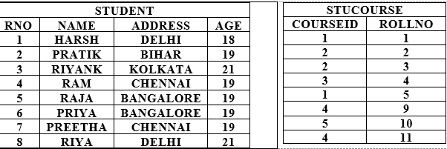

INNER JOIN: The INNER JOIN keyword selects all rows from both the tables as long as the condition satisfies. This keyword will create the result-set by combining all rows from both the tables where the condition satisfies i.e value of the common field will be same | SELECT StudentCourse.COURSEID, Student.NAME, Student.AGE FROM Student  INNER JOIN StudentCourse  ON Student.ROLLNO = StudentCourse.ROLLNO; | COURSEID NAME AGE  ---------- ---------- ----------  1 HARSH 18  2 PRATIK 19  2 RIYANK 21  3 RAM 19  1 RAJA 19
LEFT JOIN: This join returns all the rows of the table on the left side of the join and matching rows for the table on the right side of join.  The complete rows which does not match on the right side, the left hand rows will be displayed with the null values for the right hand columns | SELECT StudentCourse.COURSEID, Student.NAME, Student.AGE FROM Student  LEFT JOIN StudentCourse  ON Student.ROLLNO = StudentCourse.ROLLNO; | COURSEID NAME AGE  ---------- ---------- ----------  1 HARSH 18  2 PRATIK 19  2 RIYANK 21  3 RAM 19  1 RAJA 19  RIYA 21  PRIYA 19  PREETHA 19
RIGHT JOIN: This join returns all the rows of the table on the left side of the join and matching rows for the table on the right side of join.  The complete rows which does not match on the left side, the right hand rows will be displayed with the null values for the left hand columns | SELECT StudentCourse.COURSEID, Student.NAME, Student.AGE FROM Student  RIGHT JOIN StudentCourse  ON Student.ROLLNO = StudentCourse.ROLLNO; | 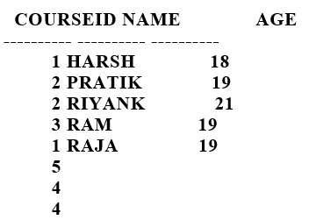
FULL JOIN: FULL JOIN creates the result-set by combining result of both LEFT JOIN and RIGHT JOIN. The result-set will contain all the rows from both the tables. The rows for which there is no matching, the result-set will contain NULL values. | SELECT StudentCourse.COURSEID, Student.NAME, Student.AGE FROM Student  2 FULL JOIN StudentCourse  3 ON Student.ROLLNO = StudentCourse.ROLLNO; | 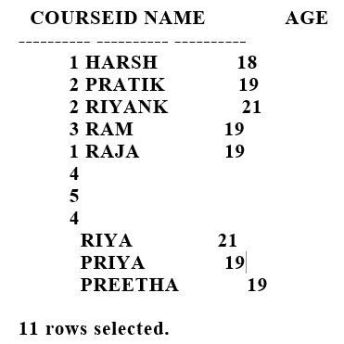

- Explain Joins in SQL with Examples

JOINS

SQL JOINS are used to retrieve data from multiple tables. A SQL JOIN is performed whenever two or more tables are listed in a SQL statement.

Here is two table tableX and tableY and they have no duplicate rows in each. In tableX the values ( A,B) are unique and in tableY the values (E,F) are unique, but the values (C and D) are common in both the tables.

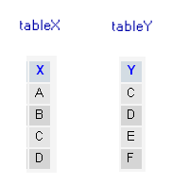

INNER JOIN OR JOIN | Inner JOIN returns all rows from tables where the key record of one table is equal to the key records of another table.  An inner join of A and B gives the result of A intersect B  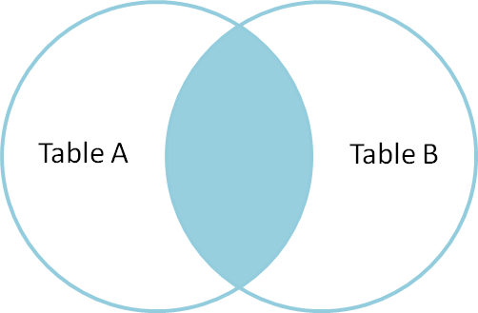 | SELECT *  FROM tableX  INNER JOIN tableY on tableX.X = tableY.Y;  SELECT *  FROM tableX as X1  INNER JOIN tableY as Y1 on X1.X = Y1.Y; | 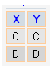
LEFT OUTER JOIN | includes all the rows from a left table of JOIN clause and the unmatched rows from a right table with NULL values for selected columns.  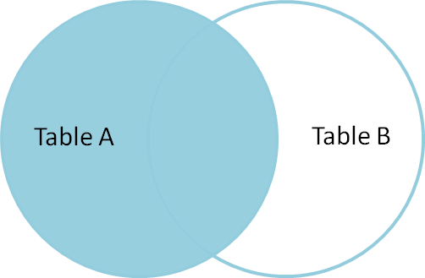 | SELECT *  FROM tableX  LEFT OUTER JOIN tableY ON tableX.X= tableY.Y | 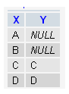
RIGHT OUTER JOIN | join includes all rows from the right of JOIN cause and the unmatched rows from the left table with NULL values for selected columns.  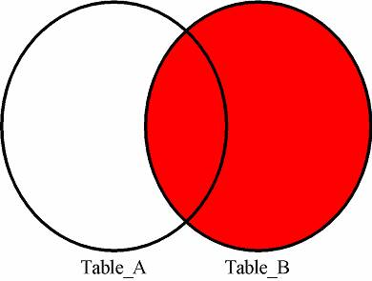 | SELECT * FROM tableX  RIGHT OUTER JOIN tableY ON tableX.X= tableY.Y | 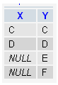
FULL OUTER JOIN | FULL OUTER JOIN, in this join, includes the matching rows from the left and right tables of JOIN clause and the unmatched rows from left and right table with NULL values for selected columns.  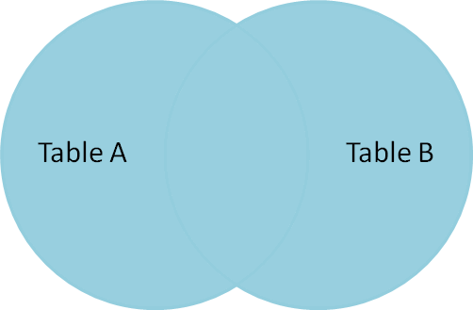 | SELECT *  FROM tableX  FULL OUTER JOIN tableY ON tableX.X= tableY.Y | 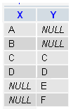

- Explain Relational Algebra in Detail with examples
- Create commands for Grant and Revoke Command. Explain the transactions of Grant and revoke with examples

- Explain Set Operation in SQL with detailed example
The SQL Set operation is used to combine the two or more SQL SELECT statements.
Types of Set Operation
Union
UnionAll
Intersect
Minus

SELECT * FROM FIRST | ID NAME  ---------- ----------  1 JACKSON  2 STEPHEN  3 DAVID  4 RAM
SELECT * FROM SECOND | ID1 NAME1  ---------- ----------  5 JACKSON  6 RAM  7 ALHAB  8 STEPHAN  1 JACKSON  4 RAM
SELECT * FROM FIRST UNION SELECT * FROM SECOND; | ID NAME  ---------- ----------  1 JACKSON  2 STEPHEN  3 DAVID  4 RAM  5 JACKSON  6 RAM  7 ALHAB  8 STEPHAN
Union All  Union All operation is equal to the Union operation. It returns the set without removing duplication and sorting the data. | SQL> SELECT * FROM FIRST UNION ALL SELECT * FROM SECOND;  ID NAME  ---------- ----------  1 JACKSON  2 STEPHEN  3 DAVID  4 RAM  5 JACKSON  6 RAM  7 ALHAB  8 STEPHAN  1 JACKSON  4 RAM  10 rows selected.
Intersect  It is used to combine two SELECT statements. The Intersect operation returns the common rows from both the SELECT statements.  In the Intersect operation, the number of datatype and columns must be the same.  It has no duplicates and it arranges the data in ascending order by default.  Syntax | SQL> SELECT * FROM FIRST INTERSECT SELECT * FROM SECOND;  ID NAME  ---------- ----------  1 JACKSON  4 RAM
. Minus  It combines the result of two SELECT statements. Minus operator is used to display the rows which are present in the first query but absent in the second query.  It has no duplicates and data arranged in ascending order by default. | SQL> SELECT * FROM FIRST MINUS SELECT * FROM SECOND;  ID NAME  ---------- ----------  2 STEPHEN  3 DAVID

- Given the Table called as Product
Create an Explicit Cursor and display the company which has the maximum count of products.
_{PRODUCTNAME} | _{COMPANY} | _{RATE} | _{QTY} | _{COST}
_{ITEM1} | _{COM1} | ₂ | ₁₀ | ₂₀
_{ITEM2} | _{COM2} | ₃ | ₂₅ | ₇₅
_{ITEM3} | _{COM1} | ₂ | ₃₀ | ₆₀
_{ITEM4} | _{COM3} | ₅ | ₁₀ | ₅₀
_{ITEM5} | _{COM2} | ₂ | ₂₀ | ₄₀
_{ITEM6} | _{COM1} | ₃ | ₂₅ | ₇₅
_{ITEM7} | _{COM2} | ₃ | ₁₀ | ₃₀
_{ITEM8} | _{COM1} | ₅ | ₁₀ | ₅₀
_{ITEM9} | _{COM3} | ₁₀ | ₆ | ₆₀
_{ITEM10} | _{COM3} | ₁₅ | ₁₀ | ₁₅₀

- Explain PL/SQL program to find the addition of 2 Numbers using
Procedure (IN and OUT Parameter)
Function (with RETURN Values)

ADD 2 NUMBERS USING PROCEDURE
DECLARE
a number :=&a;
b number :=&b;
c number;

PROCEDURE add(a IN number, b in number, c OUT number) IS
BEGIN
c := a+b;
END;

BEGIN

add(a,b,c);
dbms_output.put_line(' Sum is : ' || c);
END;
/
SQL> @SUM1.SQL;
Enter value for a: 12
old 2: a number :=&a;
new 2: a number :=12;
Enter value for b: 23
old 3: b number :=&b;
new 3: b number :=23;
Sum is : 35

PL/SQL procedure successfully completed.

declare
a1 number;
b1 number;
r1 number;
res number;

ADD 2 NUMBERS USING FUNCTION

FUNCTION SUM1(a in number, b in number)
return number is
res number;
BEGIN
res := a + b;
return res;
END;

BEGIN
a1 := &a1;
b1 := &b1;
r1 := sum1(a1,b1);
dbms_output.put_line(' Sum is : ' || r1);
END;
/

SQL> @sum2.sql;
Enter value for a1: 12
old 18: a1 := &a1;
new 18: a1 := 12;
Enter value for b1: 12
old 19: b1 := &b1;
new 19: b1 := 12;
Sum is : 24

PL/SQL procedure successfully completed.

- Write a PL/SQL program for Predefined Exception and User Defined Exception

- Create a Table called as Employee with the following fields empname, empno and empsalary.
Insert 10 records to table.

Create table employee (empname varchar2(15), empno number(2), empsalary number(3))

Create a Explicit cursor to select the five highest paid employees from the employee table and insert the Top 5 highest paid employees into the TEMP table and display the values of the TEMP Table

Create table temp as select * from employee where empno >5;

DECLARE
stu_id student.stuid%type := &stu_id;
stu_name student.stuname%type;
stu_age student.stuage%type;
-- user defined exception
ex_invalid_age EXCEPTION;
BEGIN
SELECT stuname ,stuage INTO stu_name , stu_age
FROM student
WHERE stuid = stu_id;
IF stu_age < 18 THEN
RAISE ex_invalid_age;
else
DBMS_OUTPUT.PUT_LINE ('Student Name: '|| stu_name);
DBMS_OUTPUT.PUT_LINE ('Student ID: ' || stu_id);
DBMS_OUTPUT.PUT_LINE ('Student Age: ' || stu_age);
END IF;
EXCEPTION
WHEN ex_invalid_age THEN
dbms_output.put_line('Age must be greater than 18!');
WHEN no_data_found THEN
dbms_output.put_line('No Student Available');
WHEN others THEN
dbms_output.put_line('Error...');
END;

Enter value for stu_id: 1
old 2: stu_id student.stuid%type := &stu_id;
new 2: stu_id student.stuid%type := 1;
No Student Available

PL/SQL procedure successfully completed.

SQL> /
Enter value for stu_id: 100
old 2: stu_id student.stuid%type := &stu_id;
new 2: stu_id student.stuid%type := 100;
Student Name: HARI
Student ID: 100
Student Age: 21

PL/SQL procedure successfully completed.

SQL> /
Enter value for stu_id: 3
old 2: stu_id student.stuid%type := &stu_id;
new 2: stu_id student.stuid%type := 3;
Student Name: DEEPA
Student ID: 3
Student Age: 19

PL/SQL procedure successfully completed.

SQL> /
Enter value for stu_id: 4
old 2: stu_id student.stuid%type := &stu_id;
new 2: stu_id student.stuid%type := 4;
Age must be greater than 18!

PL/SQL procedure successfully completed.

- Explain the concept of Functional Dependencies in DBMS

Functional Dependency (FD) is a constraint that determines the relation of one attribute to another attribute in a Database Management System (DBMS).
A functional dependency is denoted by an arrow "→". The functional dependency of X on Y is represented by X → Y. Let's understand Functional Dependency in DBMS with example.
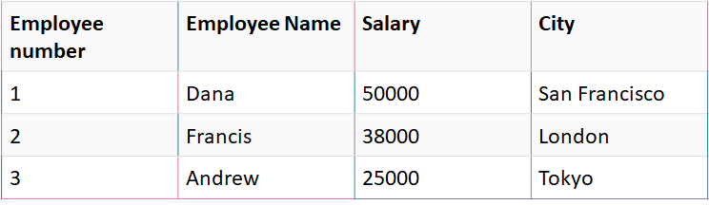
In this example, if we know the value of Employee number, we can obtain Employee Name, city, salary, etc. By this, we can say that the city, Employee Name, and salary are functionally depended on Employee number. | EMPNOENAME  EMPNOSALARY  EMPNOCITY
An attribute in a relational model is said to be functionally dependent on another attribute in the table if it can take only one value for a given value of the attribute upon which it is functionally dependent.
Types of Functional Dependencies in DBMS
There are mainly four types of Functional Dependency in DBMS. Following are the types of Functional Dependencies in DBMS:
- Multivalued Dependency
- Trivial Functional Dependency
- Non-Trivial Functional Dependency
- Transitive Dependency
Multivalued dependency
Multivalued dependency occurs in the situation where there are multiple independent multivalued attributes in a single table
  roll_no | name | age
  42 | abc | 17
  43 | pqr | 18
  44 | xyz | 18
Here, roll_no → {name, age} is a multivalued functional dependency, since the dependents name & age are not not dependent on each other(i.e. name → age or age → name doesn’t exist !)
Trivial Functional Dependency in DBMS
A trivial functional dependency occurs when you describe a functional dependency of an attribute on a collection of attributes that includes the original attribute.  A dependent is always a subset of the determinant.  For example, {X, Y} -> Y is a trivial functional dependency, as is  dependency if Y is a subset of X. | 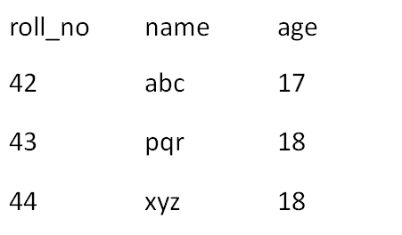
Here, {roll_no, name} → name is a trivial functional dependency, since the dependent name is a subset of determinant set {roll_no, name}
Similarly, roll_no → roll_no is also an example of trivial functional dependency.
Non Trivial Functional Dependency in DBMS
Functional dependency which also known as a nontrivial dependency occurs when XY holds true where Y is not a subset of X.  In Non-trivial functional dependency, the dependent is strictly not a subset of the determinant.  i.e. If X → Y and Y is not a subset of X, then it is called Non-trivial functional dependency.. | 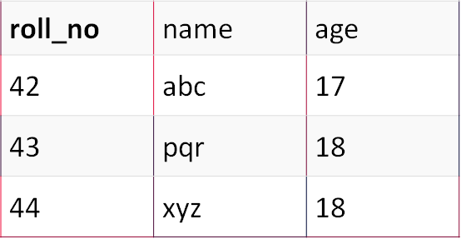
roll_no → name is a non-trivial functional dependency, since the dependent name is not a subset of determinant roll_no
Similarly, {roll_no, name} → age is also a non-trivial functional dependency, since age is not a subset of {roll_no, name}
Transitive Dependency in DBMS
In transitive functional dependency, dependent is indirectly dependent on determinant.  i.e. If a → b & b → c, then according to axiom of transitivity, a → c. This is a transitive functional dependency | 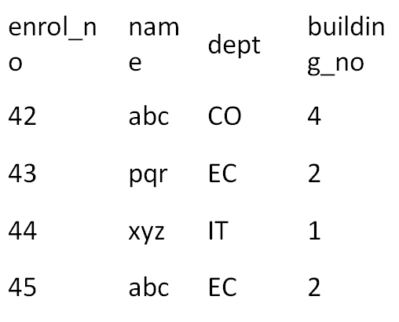
enrol_no → dept and dept → building_no,
enrol_no → building_no is a valid functional dependency.
This is an indirect functional dependency, hence called Transitive functional dependency.Note:
You need to remember that transitive dependency can only occur in a relation of three or more attributes.
AB, BC, CA

- Explain Normalization with an Example

Normalization is a process of organizing the data in database to avoid data redundancy
insertion anomaly,
update anomaly
deletion anomaly

Anomalies in DBMS

Insert Anomalies - An Insert Anomaly occurs when certain attributes cannot be inserted into the database without the presence of other attributes
Update Anomalies -An update anomaly is a data inconsistency that results from data redundancy and a partial update.
Delete Anomalies - A deletion anomaly occurs when you delete a record that may contain attributes that shouldn't be deleted.

Suppose a company wants to store the names and contact details of its employees. It creates a table that looks like this: | 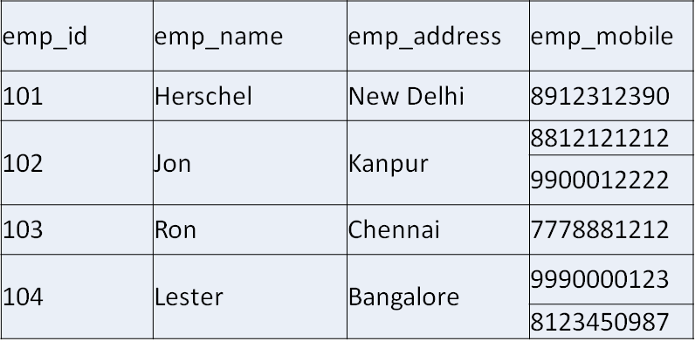
First normal form (1NF)
An attribute (column) of a table cannot hold multiple values.
Each Column should contain only atomic values.
There are no repeating groups of columns.

Two employees (Jon & Lester) are having two mobile numbers so the company stored them in the same field as you can see in the table above.

This table is not in 1NF as the rule says “each attribute of a table must have atomic (single) values”, the emp_mobile values for employees Jon & Lester violates that rule.
To make the table complies with 1NF we should have the data like this: | 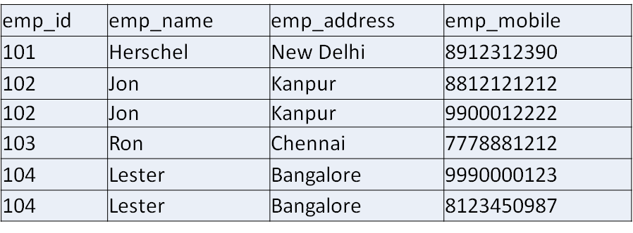
SECOND NORMAL FORM
Table is in 1NF (First normal form)
No non-prime attribute should be dependent on the one of the candidate key of table.
Non Prime Attribute should be dependent on the complete candidate key
All the columns depend on the table’s primary key.
Prime attribute − An attribute, which is a part of the candidate-key, is known as a prime attribute. | Non-prime attribute − An attribute, which is not a part of the prime-key, is said to be a non-prime attribute
Consider the Student_Project table and the candidate keys for this table is {Stu_id,Proj_id} | 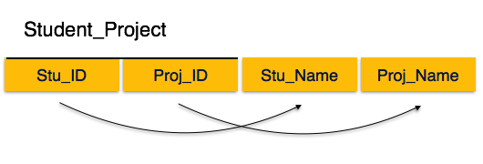
According to the rule, non-key attributes, i.e. Stu_Name and Proj_Name must be dependent upon both and not on any of the prime key attribute individually.
But we find that Stu_Name can be identified by Stu_ID and Proj_Name can be identified by Proj_ID independently.
This is called partial dependency, which is not allowed in Second Normal Form.
To bring into 2nd Normal form, Relation is depicted in 2 tables and there exists noPartial Dependency
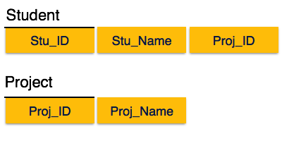
THIRD NORMAL FORM
Table must be in 2NF  Transitive functional dependency of non-prime attribute on any super key should be removed. | In this example superkey is stu_ID and  Stu_ID city  city zip
Stu_ID is the key and only prime key attribute. | 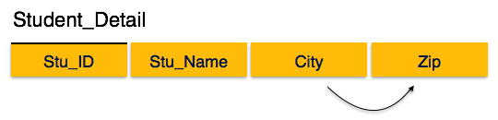
City can be identified by Stu_ID as well as Zip itself. Neither Zip is a superkey nor is City a prime attribute.  To bring this relation into third normal form, we break the relation into two relations as follows − | Additionally, Stu_ID → Zip → City, so there exists transitive dependency  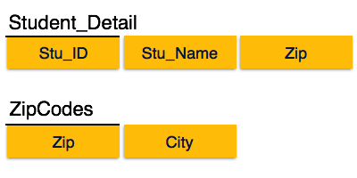
Boycee Codd Normal Form
It is an advance version of 3NF that’s why it is also referred as 3.5NF.
BCNF is stricter than 3NF.
A table complies with BCNF if it is in 3NF and for every functional dependency X->Y, X should be the super key or candidate key of the table.
Suppose there is a company wherein employees work in more than one department. |  | 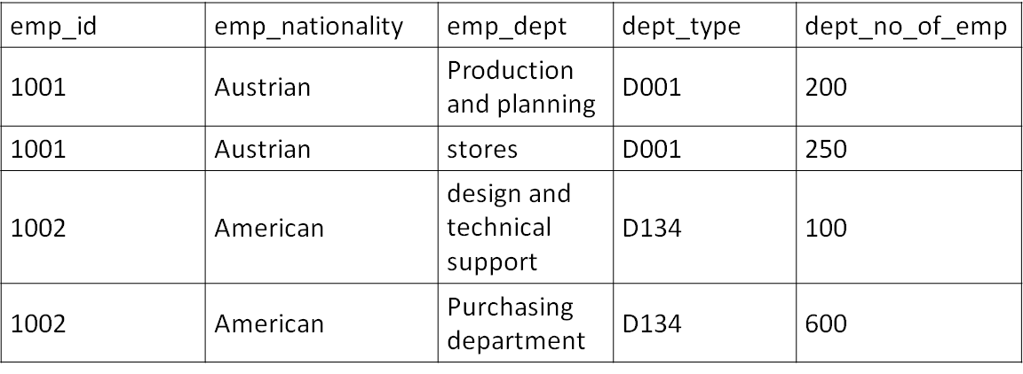
emp_id -> emp_nationality  emp_dept -> {dept_type, dept_no_of_emp}  Candidate key: {emp_id, emp_dept} |  | The table is not in BCNF as neither emp_id nor emp_dept alone are keys. Both Together is considered as candidate keys
To make the table comply with BCNF we can break the table in three tables like this: |  | emp_nationality table: (Table 1)  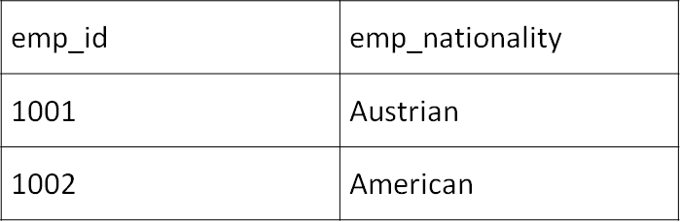
emp_dept table (Table 2)  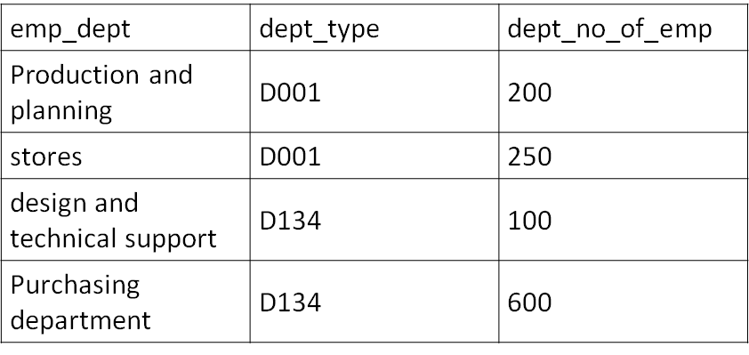 |  | emp_dept_mapping table: (Table 3)  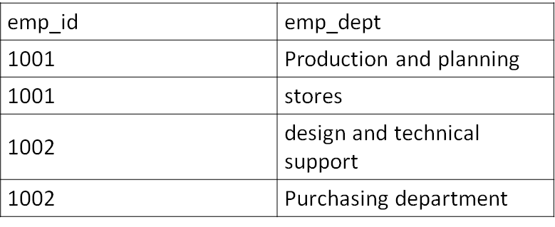

First normal form | No Multi Valued Attribute  Only SingleValue
 | In 1st Normal Form  No Partial Dependency  Only Full Dependency  AB C (AB is a candidate key and it determines C is ok but if AC or B C then it is not said in 2nd Normal Form | {Ram,Sam} are founders of company and they are asking for finance {krishna}  {Ram,Sam}{krishna} then it is good  But when either  {Ram} {Krishna}  Or  {Sam} {Krishna} then it is against the law because bcoz they are together founders and one cannot partial do some operations
3rd Normal Form | In 2nd Normal Form  No Transitive Dependency  No Non Prime attributes should determine non Prime  X Y Z  X Prime Attribute  Y Non PrimeAttribute  Z Non Prime Attribute  X Z is not possible through Y and if X Z directly is possible  Or Y Z directly is possible but indirectly through an Non Prime attribute is not possible | Ram Samkrishna  Ram is a Topper and Sam and Krishna are poor learners  Ram Says to krishna that he will take care of his studies to achieve good score.  But Sam he himself being poor learner promises to Krishna that he will make him to achieve good Score, which cannot be done so NoTransitive Dependency  If Sam himself is a topper then he can take care of Krishna’s studies
Boyce Codd Normal  Form | In 3rd Normal Form  LHS must be Candidate key or Super Key | This case of Sam himself being the topper or prime attribute is not possible in Boycecodd normal form.  LHS must be candidate key and all the other non prime should be determined only from the candidate key

- Explain the Concept of Triggers with an example for Before Insert and After Insert with a sample example

PART – C
- Case Study – ER Model For a college DB. Draw an ER diagram with Entities, relationships, Cardinalities
Assumptions :
- A college contains many departments
- Each department can offer any number of courses
- Many instructors can work in a department
- An instructor can work only in one department
- For each department there is a Head
- An instructor can be head of only one department
- Each instructor can take any number of courses
- A course can be taken by only one instructor
- A student can enroll for any number of courses
- Each course can have any number of students

Step 1: Identify the Entities
- DEPARTMENT
- STUDENT
- COURSE
- INSTRUCTOR
Step 2: Find the relationships
- One course is enrolled by multiple students and one student enrolls for multiple courses, hence the cardinality between course and student is Many to Many.
- The department offers many courses and each course belongs to only one department, hence the cardinality between department and course is One to Many.
- One department has multiple instructors and one instructor belongs to one and only one department , hence the cardinality between department and instructor is one to Many.
- Each department there is a “Head of department” and one instructor is “Head of department “,hence the cardinality is one to one .
- One course is taught by only one instructor, but the instructor teaches many courses, hence the cardinality between course and instructor is many to one.

Step 3: Identify the key attributes
- Deptname is the key attribute for the Entity “Department”, as it identifies the Department uniquely.
- Course# (CourseId) is the key attribute for “Course” Entity.
- Student# (Student Number) is the key attribute for “Student” Entity.
- Instructor Name is the key attribute for “Instructor” Entity.

Step 4: Identify other relevant attributes
- For the department entity, the relevant attribute is location
- For course entity, course name,duration,prerequisite
- For instructor entity, room#, telephone#
- For student entity, student name, date of birth
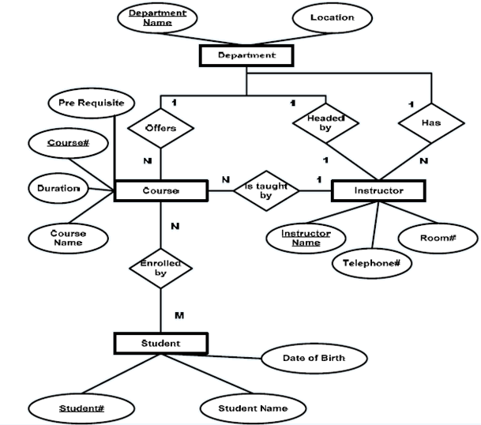
- Case Study – Banking Business Scenario
Assumptions :
- There are multiple banks and each bank has many branches. Each branch has multiple customers
- Customers have various types of accounts
- Some Customers also had taken different types of loans from these bank branches
- One customer can have multiple accounts and Loans
Perform the Following
- Identify the Entities
- Find relationships
- Identify the key attributes for every Entity
- Identify other relevant attributes
Draw complete E-R diagram with all attributes including Primary Key

Step 1: Identify the Entities
- BANK
- BRANCH
- LOAN
- ACCOUNT
- CUSTOMER

Step 2: Find the relationships
- One Bank has many branches and each branch belongs to only one bank, hence the cardinality between Bank and Branch is One to Many.
BANK:BRANCH 1:M
- One Branch offers many loans and each loan is associated with one branch, hence the cardinality between Branch and Loan is One to Many.
BRANCH :LOAN 1 : M
- One Branch maintains multiple accounts and each account is associated to one and only one Branch, hence the cardinality between Branch and Account is One to Many
BRANCH :ACCOUNT 1 : M
- One Loan can be availed by multiple customers, and each Customer can avail multiple loans, hence the cardinality between Loan and Customer is Many to Many.
LOAN:CUSTOMER M : M
- One Customer can hold multiple accounts, and each Account can be held by multiple Customers, hence the cardinality between Customer and Account is Many to Many
CUSTOMER:ACCOUNT M:M

Step 3: Identify the key attributes
- BankCode (Bank Code) is the key attribute for the Entity “Bank”, as it identifies the bank uniquely.
- Branch# (Branch Number) is the key attribute for “Branch” Entity.
- Customer# (Customer Number) is the key attribute for “Customer” Entity.
- Loan# (Loan Number) is the key attribute for “Loan” Entity.
- Account No (Account Number) is the key attribute for “Account” Entity.

Step 4: Identify other relevant attributes
- For the “Bank” Entity, the relevant attributes other than “BankCode” would be “Name” and “Address”.
- For the “Branch” Entity, the relevant attributes other than “Branch#” would be “Name” and “Address”.
- For the “Loan” Entity, the relevant attribute other than “Loan#” would be “Loan Type”.
- For the “Account” Entity, the relevant attribute other than “Account No” would be “Account Type”.
- For the “Customer” Entity, the relevant attributes other than “Customer#” would be “Name”, “Telephone#” and “Address”.
Given the Context Flow Diagram of Food Ordering System. Draw the Level 0 and Level 1 Diagram

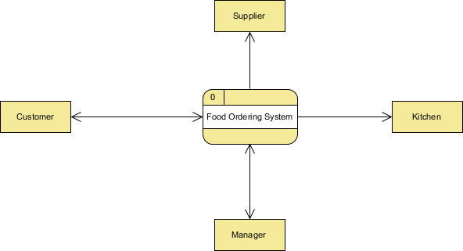

- Given the Context Flow Diagram of Lemonade System. Draw the Level 0 and Level 1 Diagram

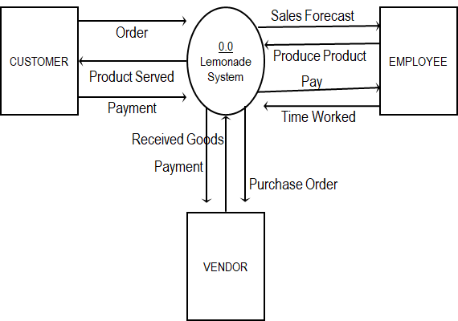

Refer DFD Question

